

Invoice Creation from Supplier Portal
User Manual – Self Service Procurement
DOCUMENTATION FOR

Submitted To
Document Control
Date | Author | Version | Change Reference
15-July-26 | Pravin.B | V1.0 | Initial Version
Change Record

Reviewers
Name | Position
Mr. Manoj Khanna. S | Project Manager, 4iapps

Approvers
Name | Position | Signature
Mr. Kamal Al Harrasi | Project Manager, OMRAN
Mr. Manoj Khanna. S | Project Manager, 4iapps

Distribution
Copy No. | Name | Location
1 | Kamal Al Harrasi | Omran Group

Contents

1 Creation of Invoice from Supplier Portal 2

Customize the text for your project, as appropriate.

Creation of Invoice from Supplier Portal

Step | Action
1. | Log in as Supplier Portal Credentials with Username and Password.
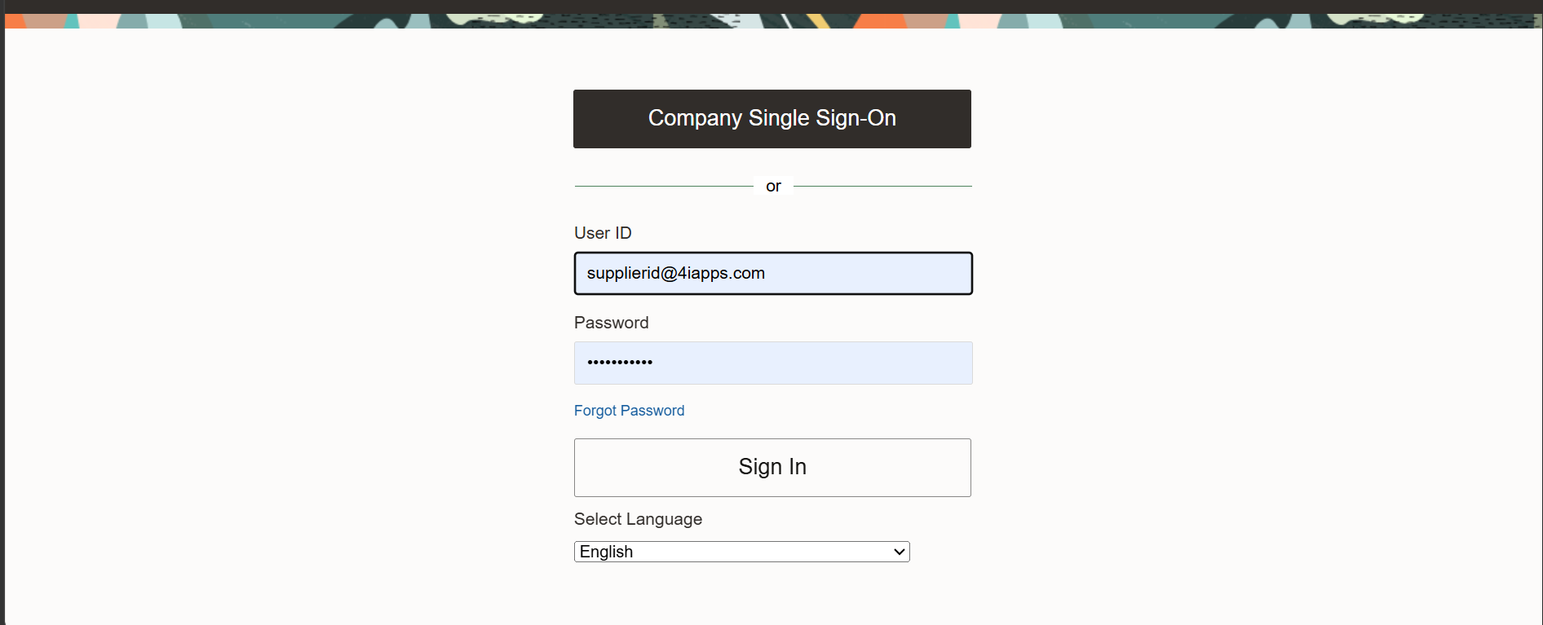

Step | Action
2. | Navigation: Supplier Portal Supplier Portal
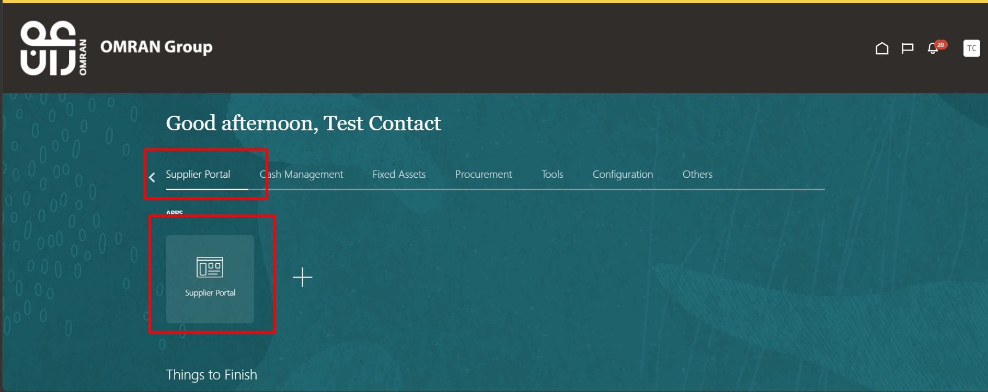

Step | Action
3. | Select Create Invoice
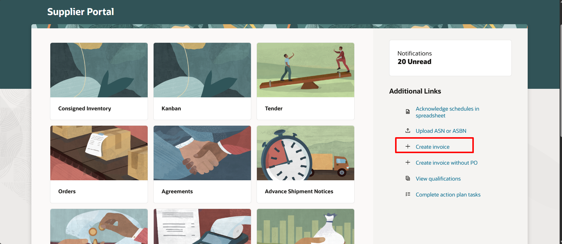

Step | Action
4. | Identifying PO Select drop down and click Search
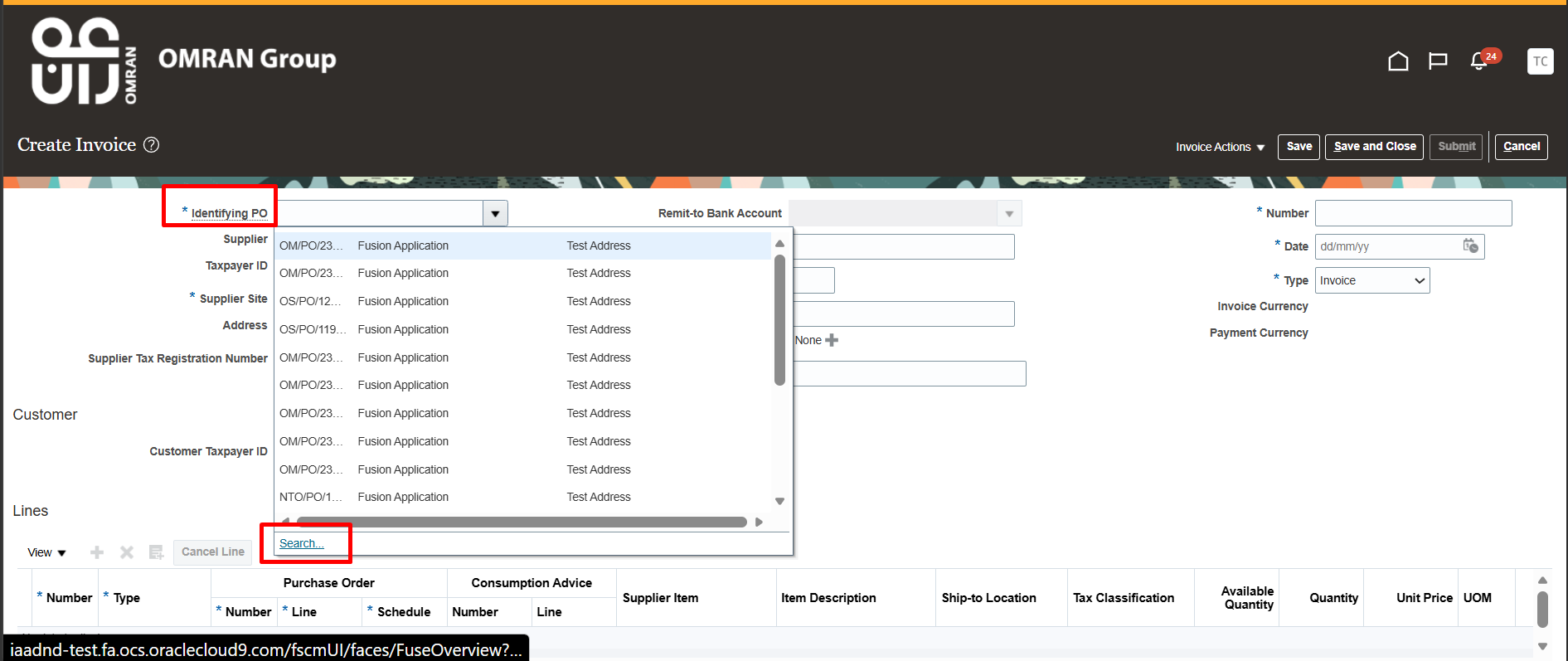

Step | Action
5. | Enter PO number and click Search
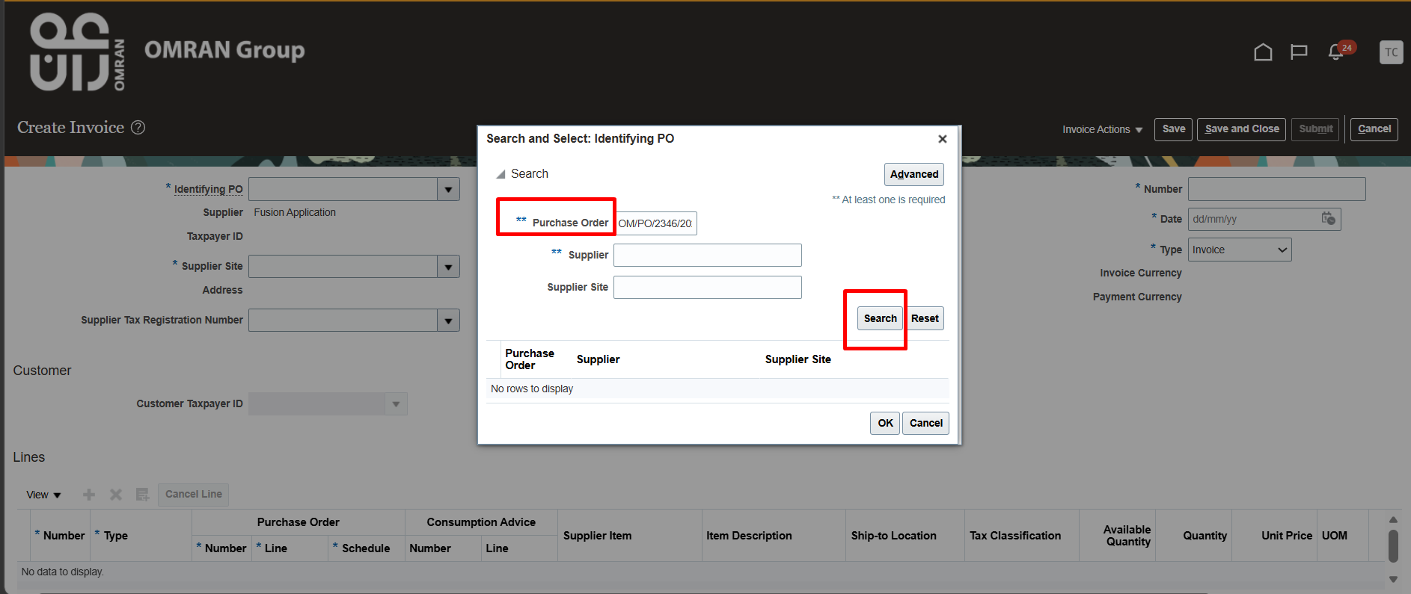

Step | Action
6. | Select PO number and click OK
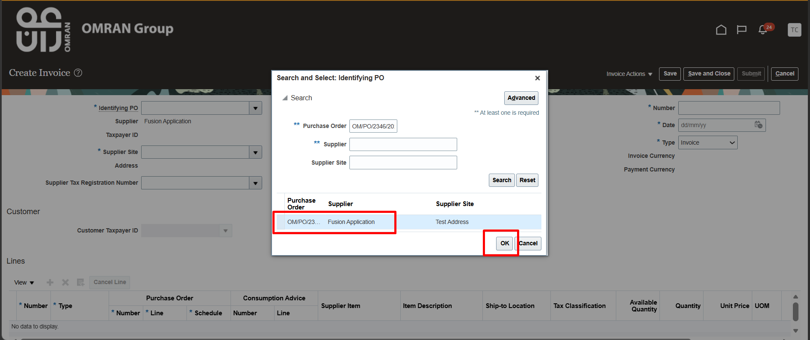

Step | Action
7. | Under Attachments Click “+” icon
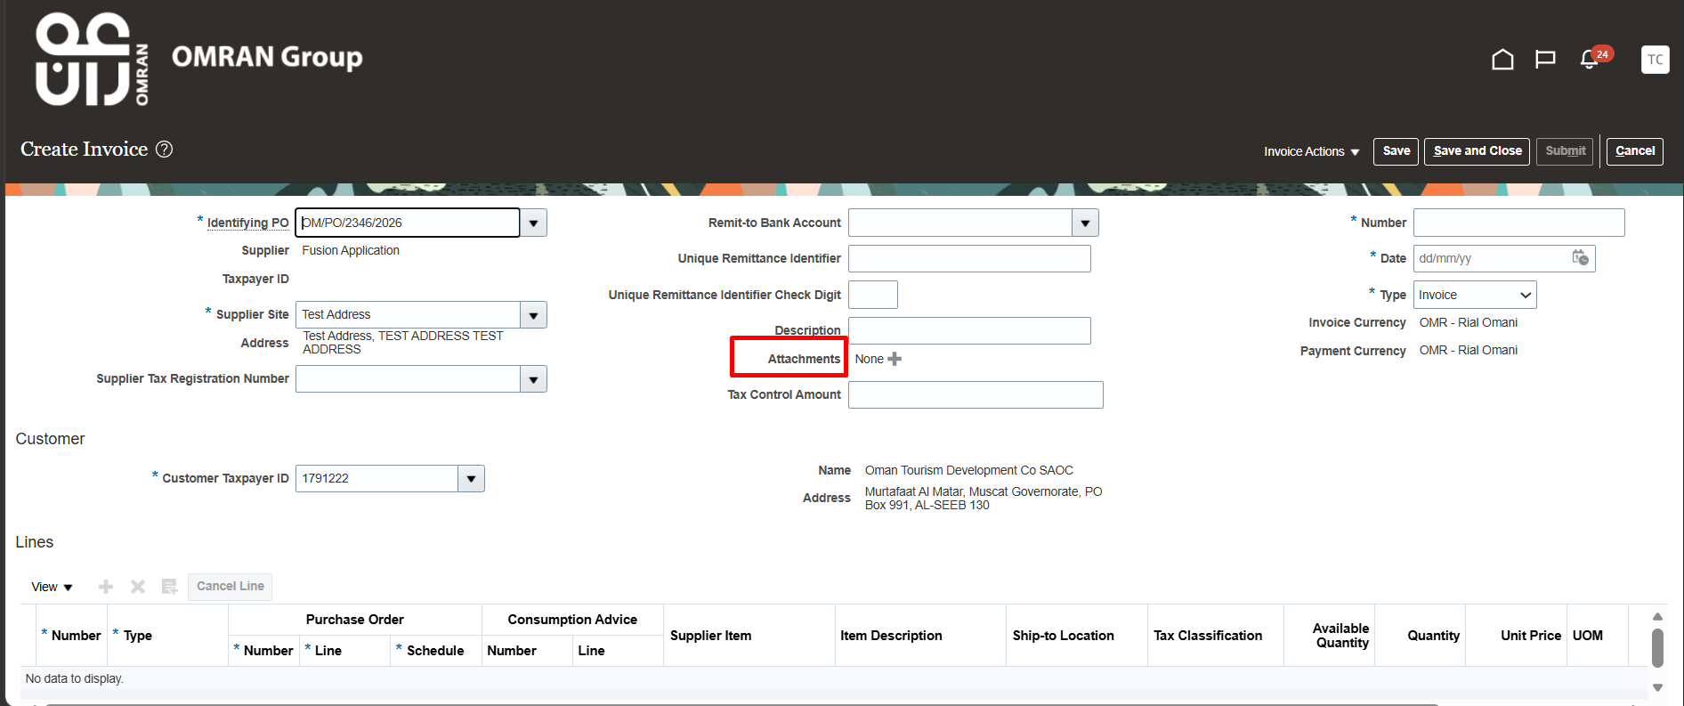

Step | Action
8. | Under Category Select “From Supplier”
9. | Attach the document, click OK
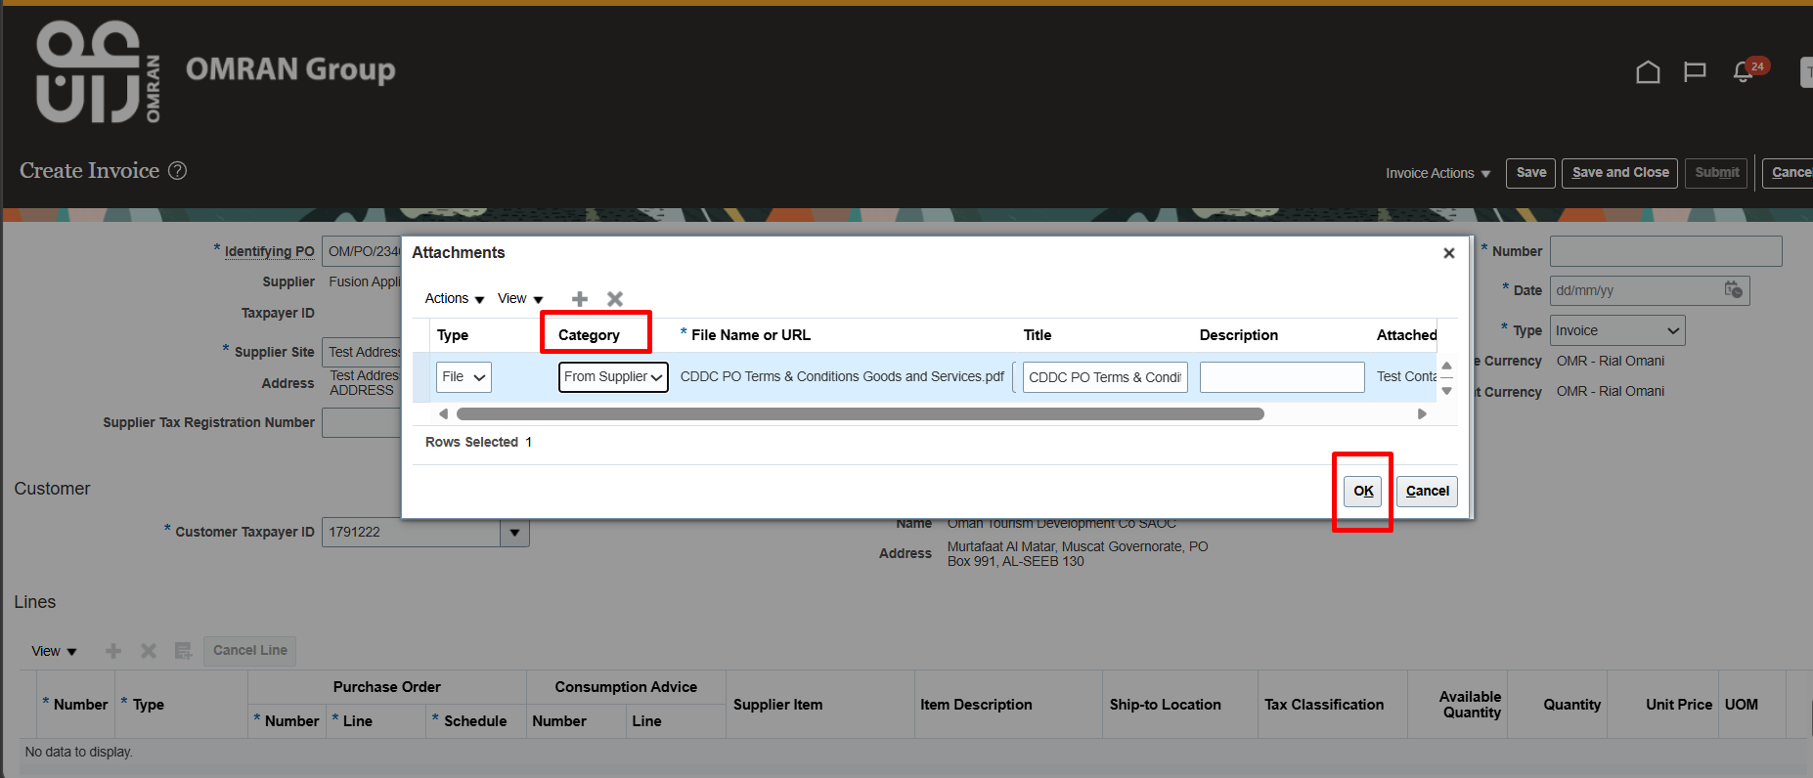

Step | Action
10. | Number Enter the Invoice Number
11. | Date Current Date (Date on which invoice is created)
12. | Type Invoice
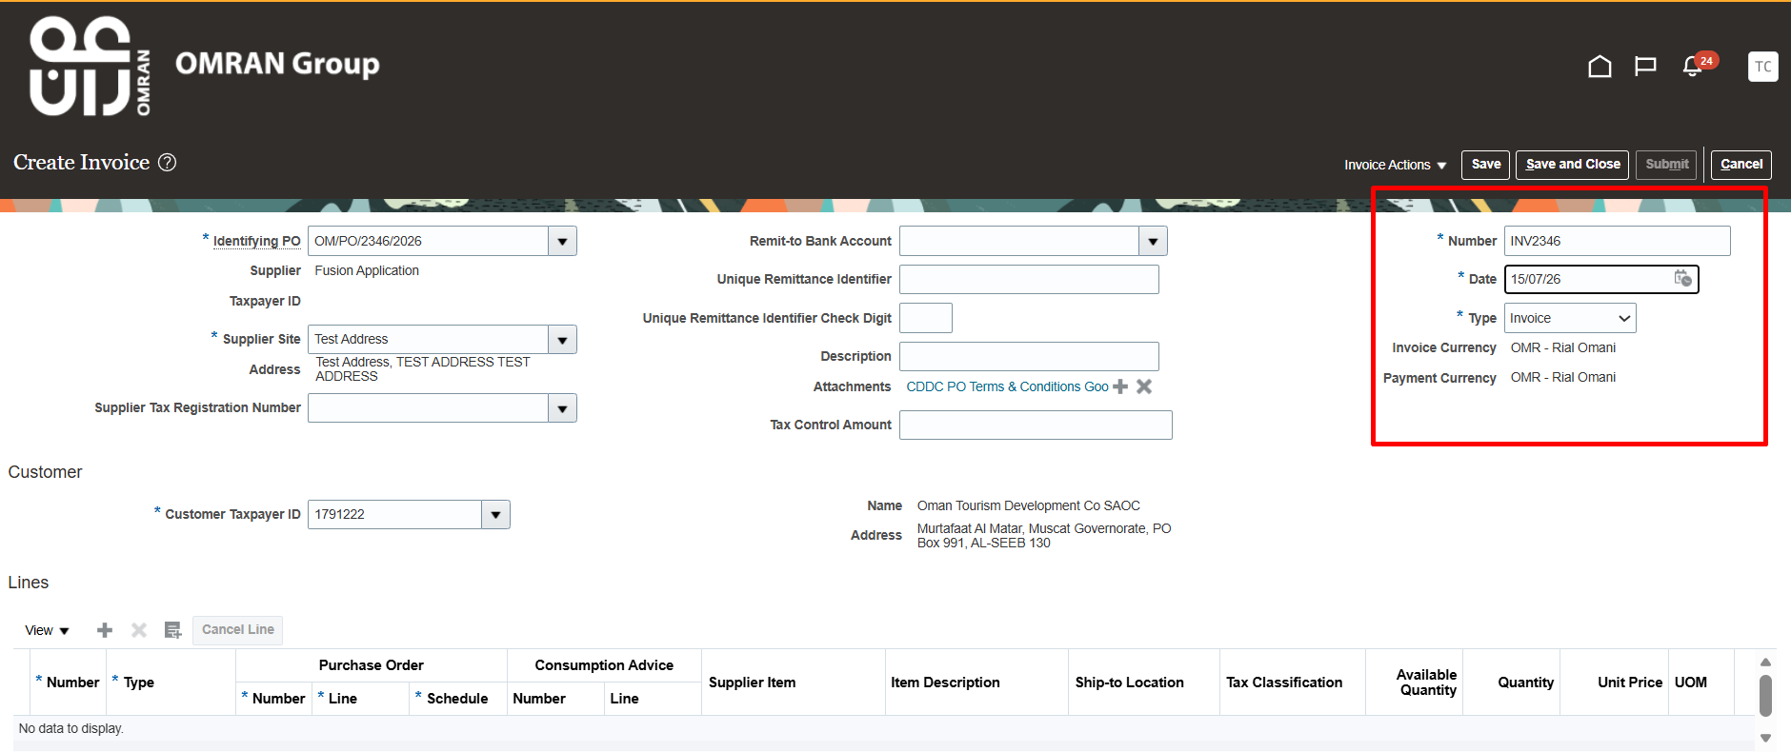

Step | Action
13. | Lines Click “Select and Add” icon
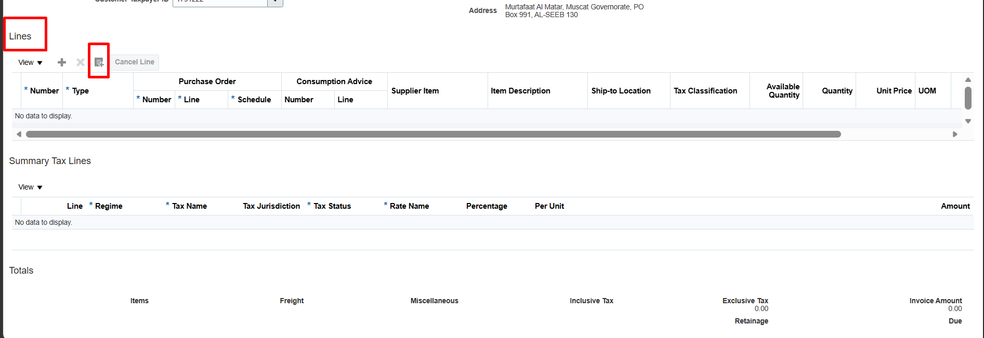

Step | Action
14. | Select PO number, click OK
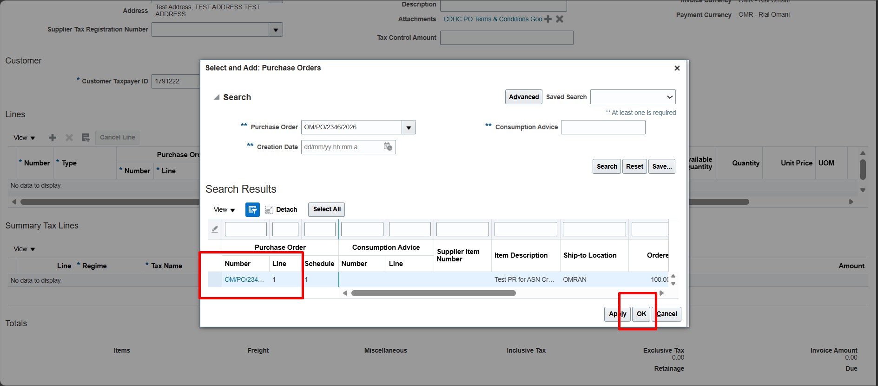

Step | Action
15. | Click on Save
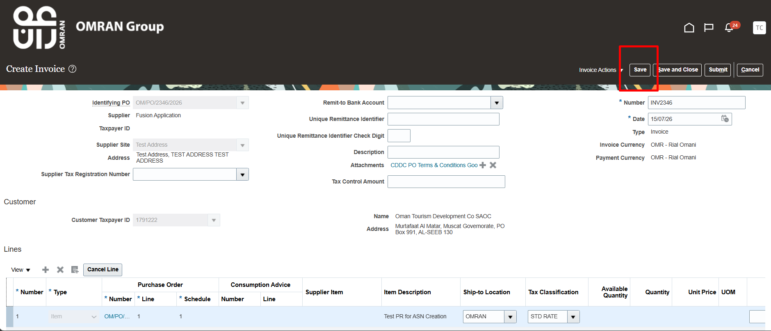

Step | Action
16. | Under Invoice Action Calculate Tax
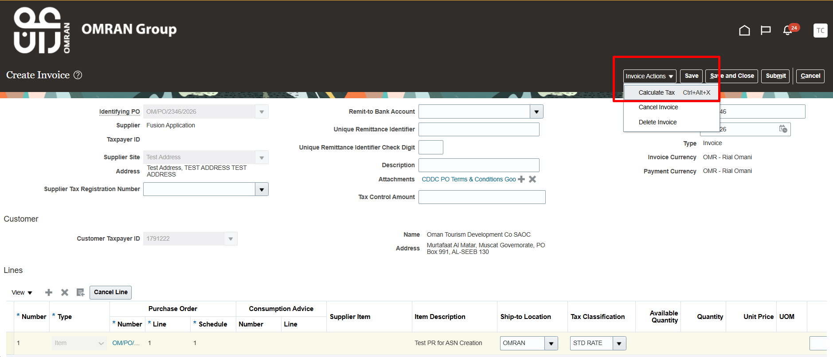

Step | Action
17. | Under Lines we can view Tax applied
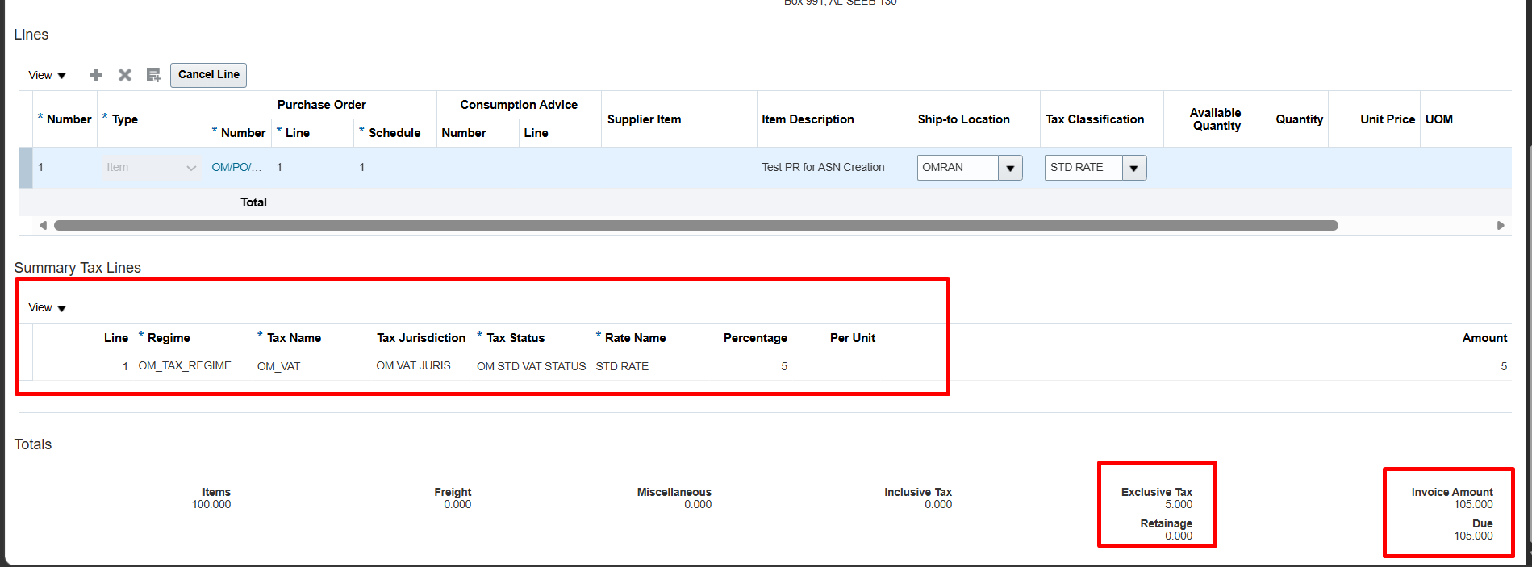

Step | Action
18. | Click Save and Submit
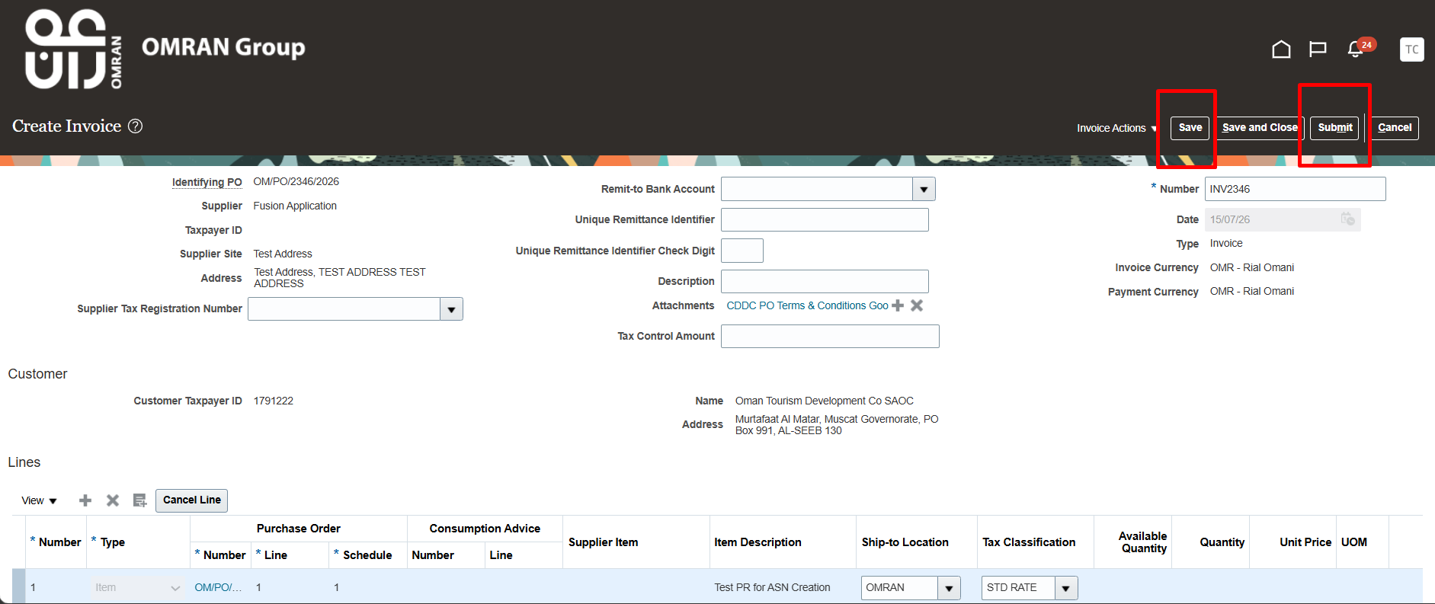

Step | Action
19. | Invoice has been created
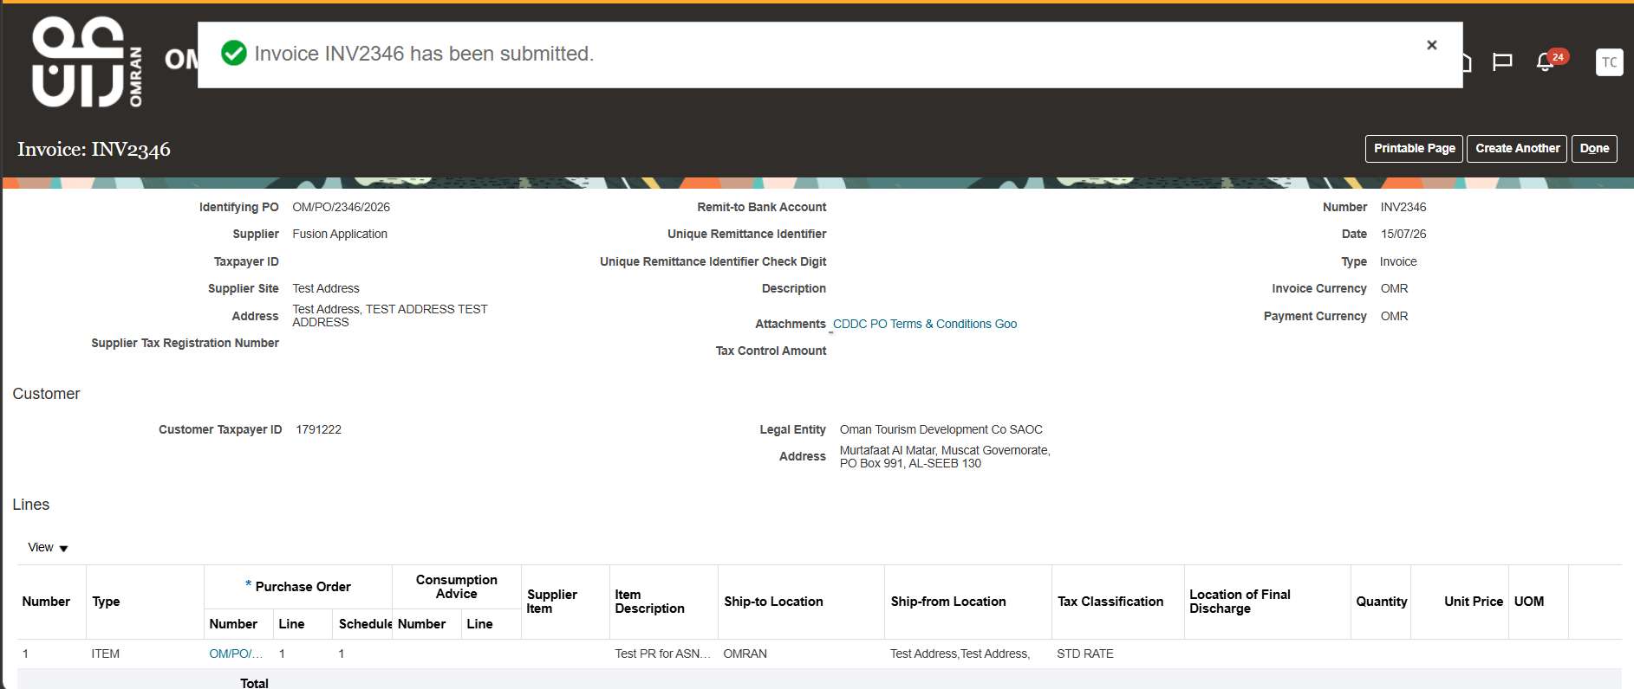

Step | Action
20. | End of Procedure

