

External Supplier Registration
User Manual – Vendor Management

DOCUMENTATION FOR

Submitted To
Document Control
Date | Author | Version | Change Reference
27-Mar-24 | Prem Kumar Rajendran | V1.0 | Initial Version
Change Record

‘
Reviewers
Name | Position
Cyril Joshua R | Solution Architect, 4iapps
Kavin Rama M | SCM Functional Consultant, 4iapps

Approvers
Name | Position | Signature
Mr. Kamal Al Harrasi | Project Manager, OMRAN
Mr. Shagul Hameed | Project Manager, 4iapps
 | Head of IT, OMRAN
 | Head of Procurement, OMRAN

Distribution
Copy No. | Name | Location
1 | Kamal Al Harrasi | Omran Group

Contents

1. External Supplier Registration 3

Customize the text for your project, as appropriate.

External Supplier Registration
Step | Action
 | Click on Supplier Registration “https://iaafbv-test.fa.ocs.oracleclou...”
 | Link will direct user to Supplier registration Page
 | Navigate to Company Details Provide all required Details

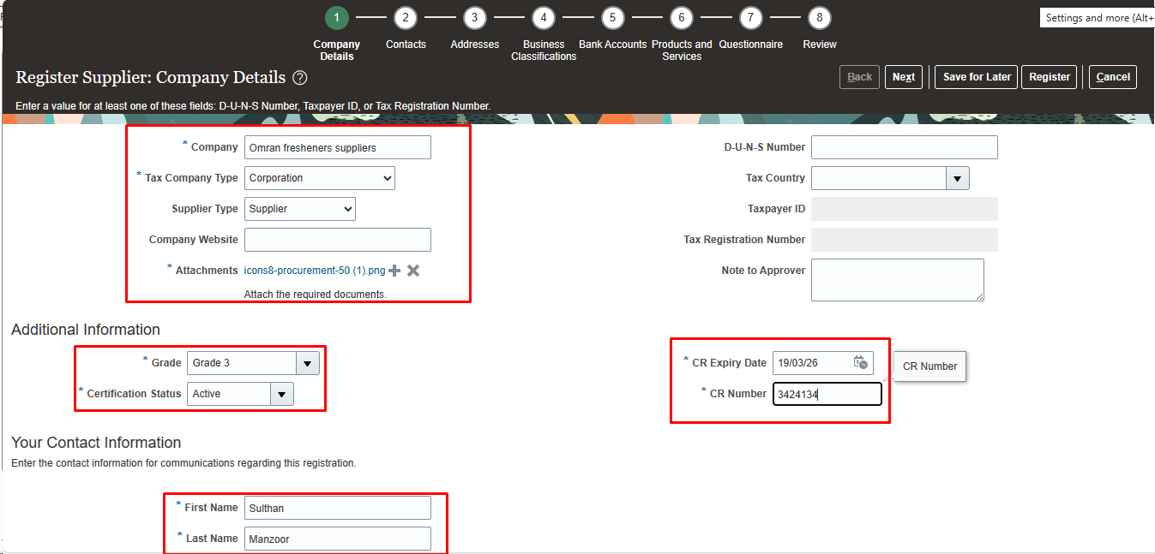

Step | Action
 | Navigate to “Contacts” Contact information Will be Populated Here from Company details from “Your Contact Information” Click on create Icon to add additional Contacts

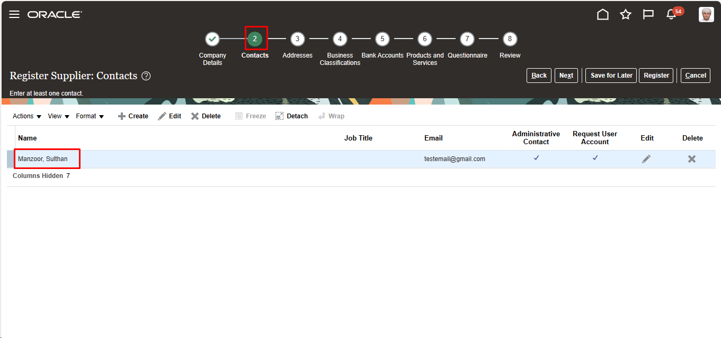
Step | Action
 | Navigate to “Create Contact” Enter the required Contact Details

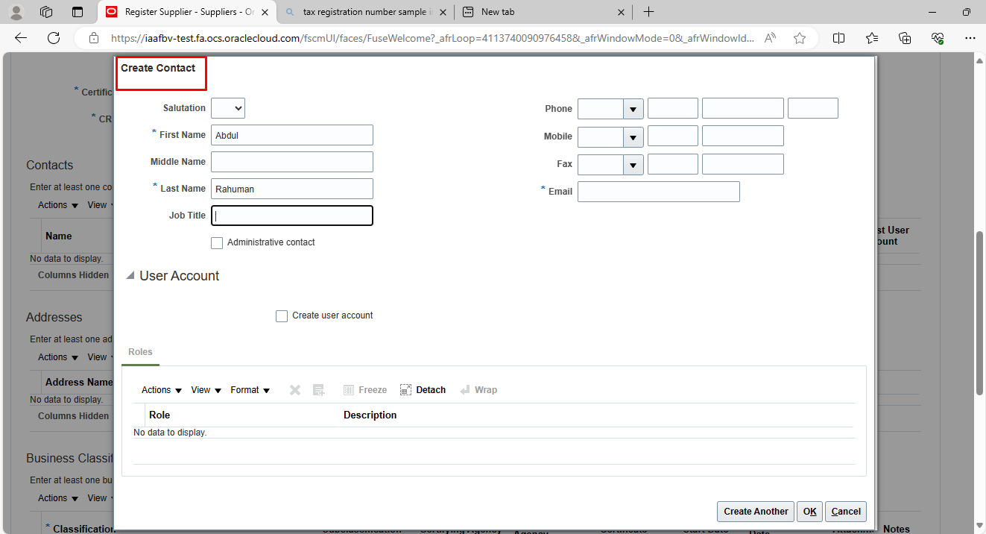
Step | Action
 | Select “Create user account” Select “Roles” Click on Select & add for any additional roles

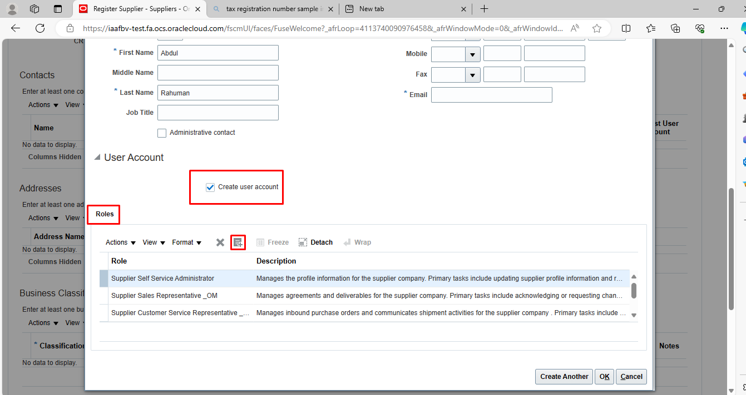
Step | Action
 | Click “OK”

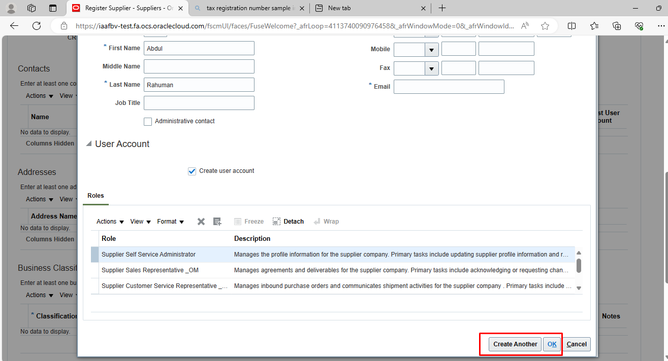
Step | Action
 | Navigate to “Addresses” Click on Create Icon

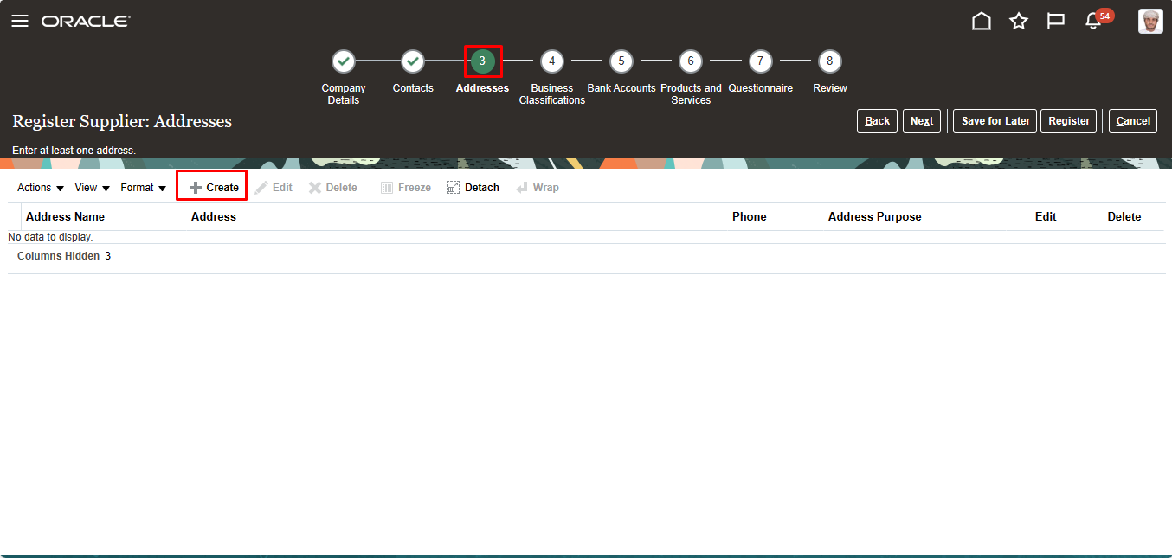
Step | Action
 | Navigate to “Create Address” Enter the required Address Details

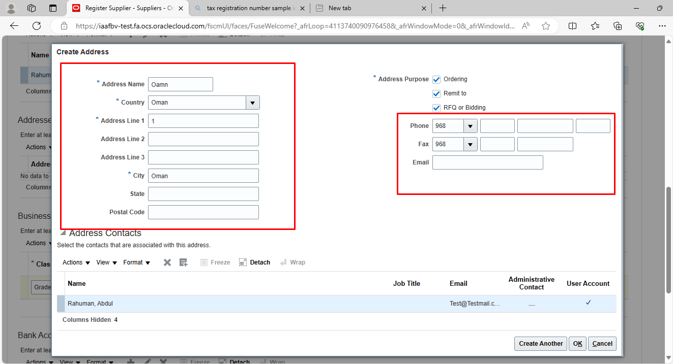
Step | Action
 | Select “Address Purpose”

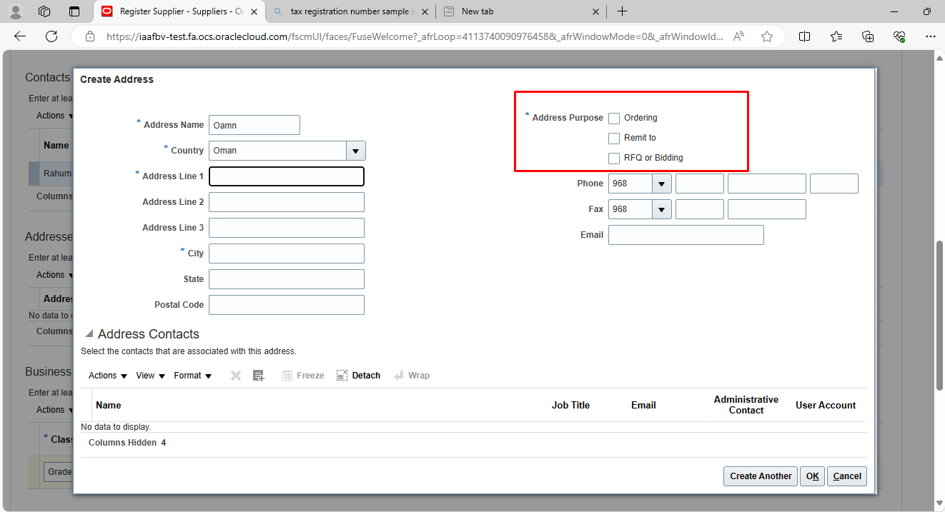
Step | Action
 | Navigate to “Address Contacts” Click on Search & Add icon

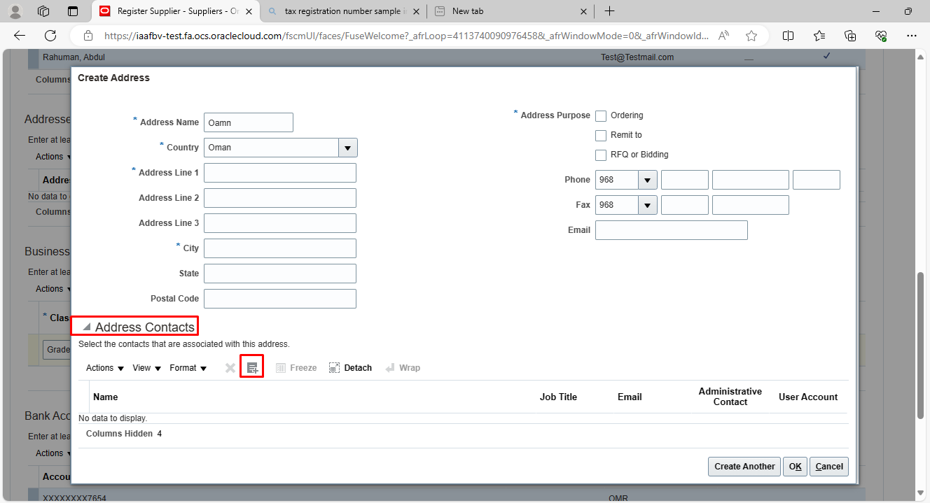
Step | Action
 | Select Contact Click “Apply”

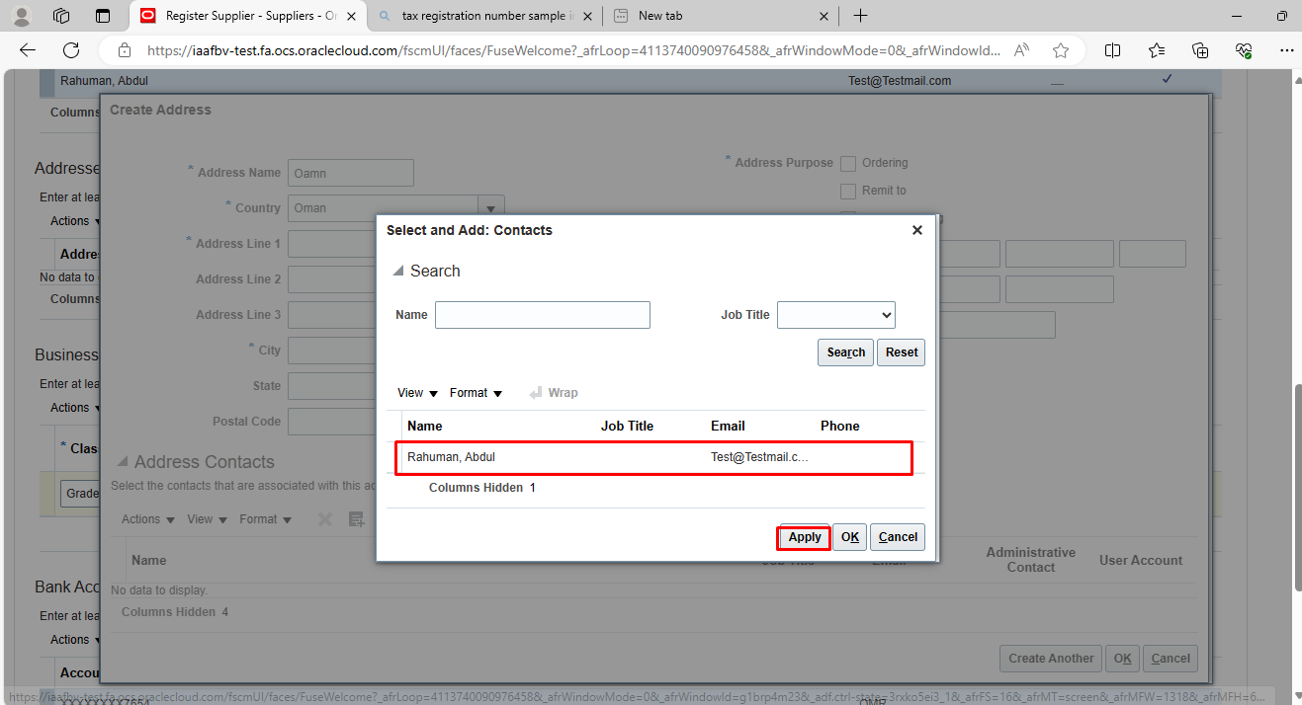
Step | Action
 | Navigate to “Business Classification” Click on “Create icon”

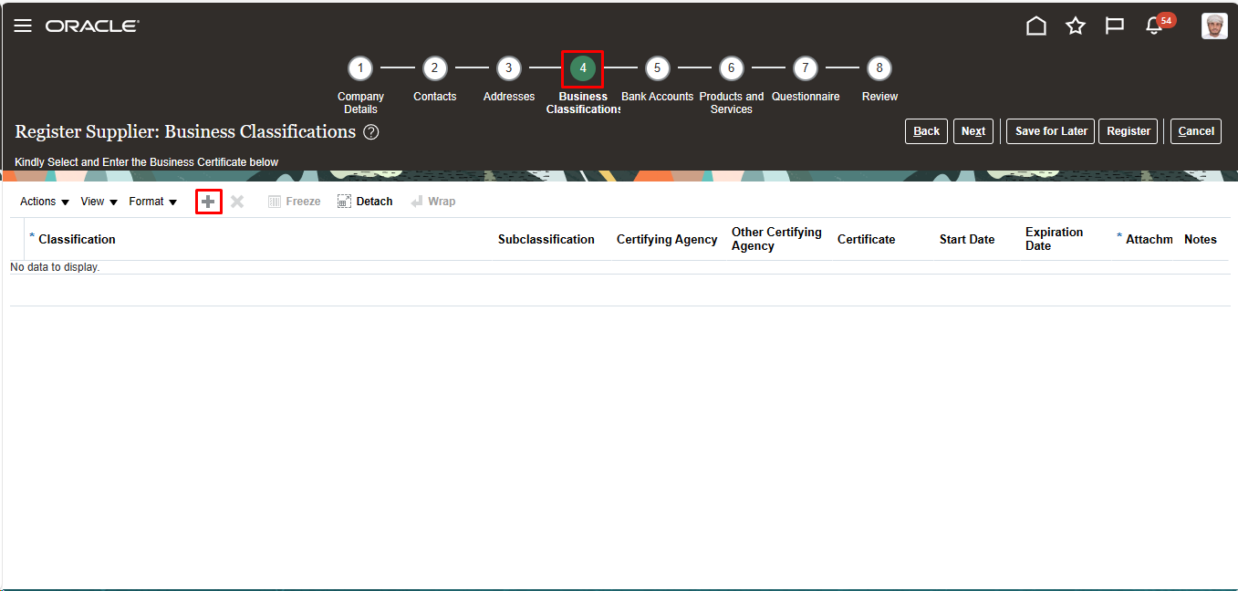
Step | Action
 | Select “Classifications” Provide all required details

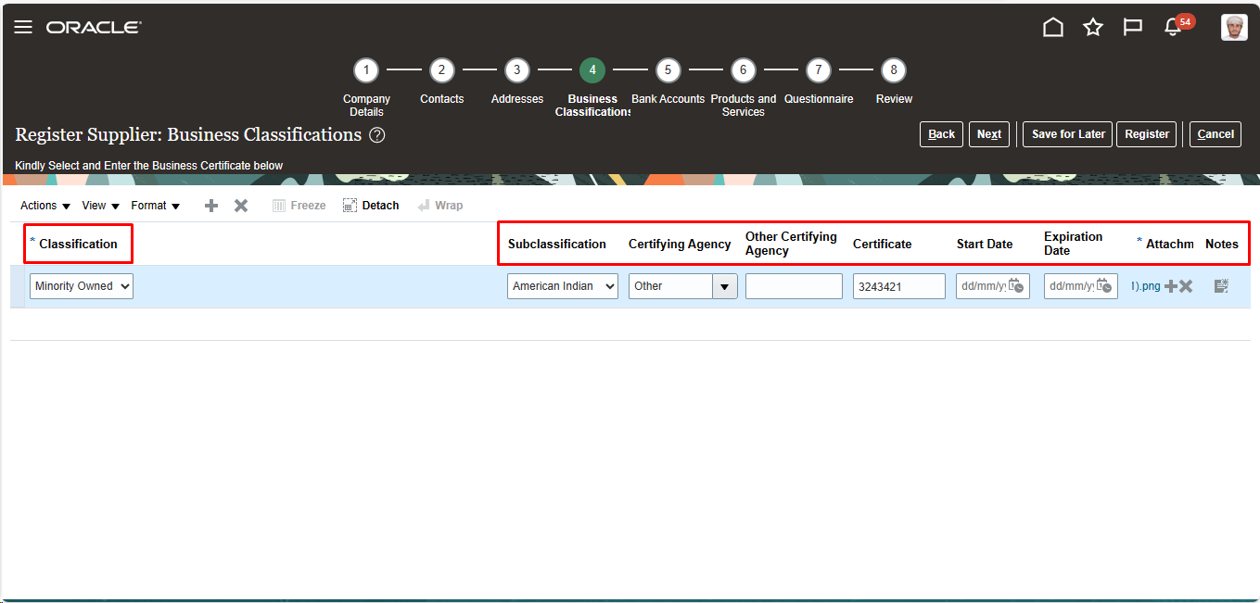
Step | Action
 | Navigate to “Bank Accounts” Click on “Create Icon”

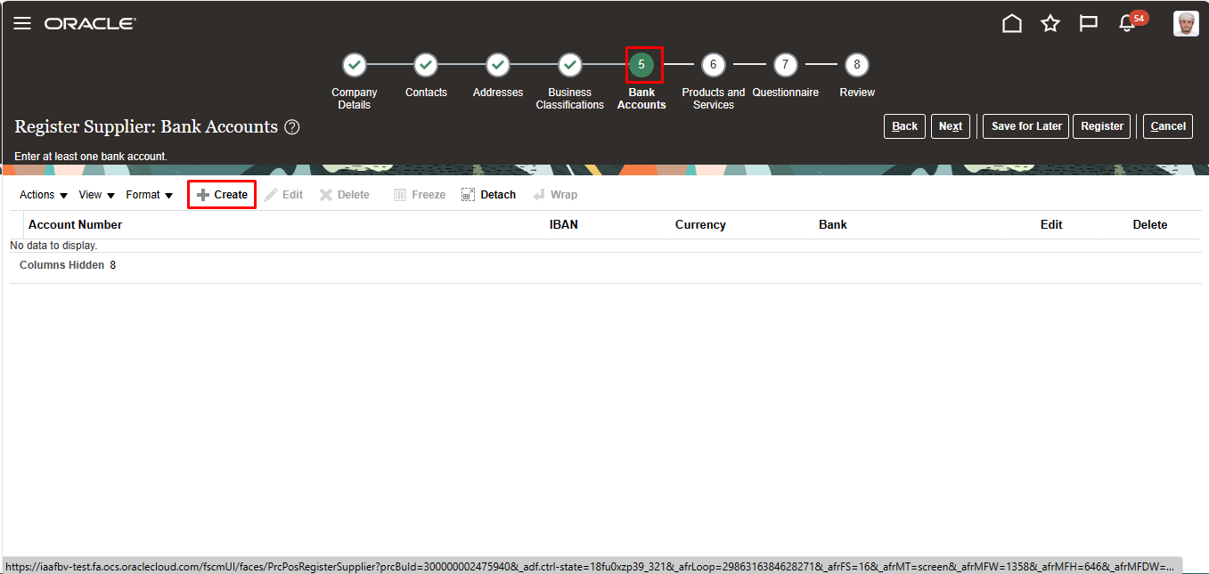
Step | Action
 | Provide All required Bank Details Click on “ok”

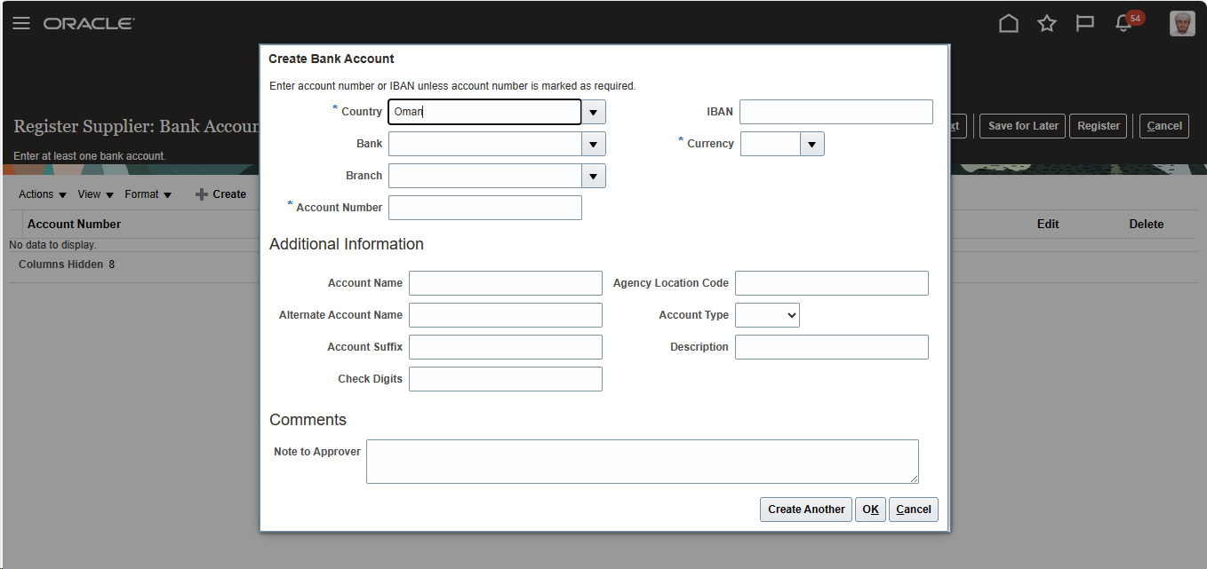

Step | Action
 | Navigate to Products and Services Categories Click on Search & Add Icon

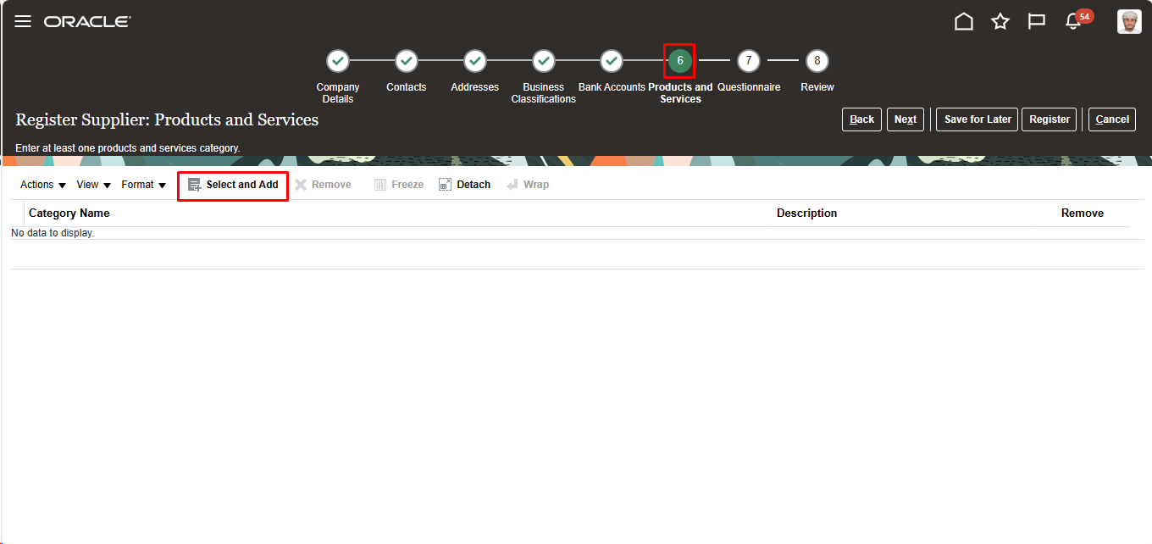
Step | Action
 | Select the Required Category name Click on “Apply”

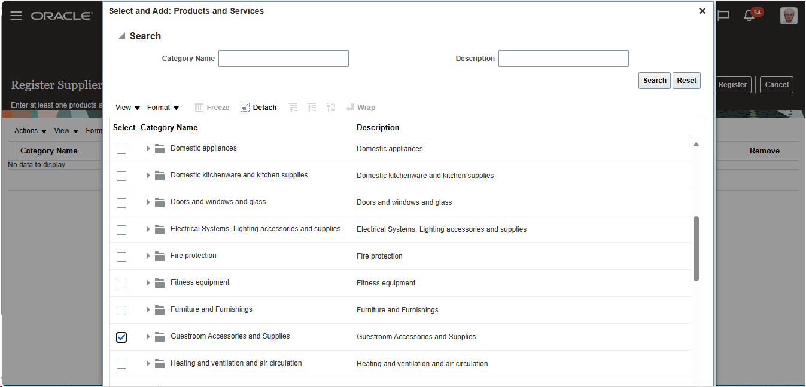
Step | Action
 | Navigate to “Questionaries Provide Answer for the questions Click on “Next”

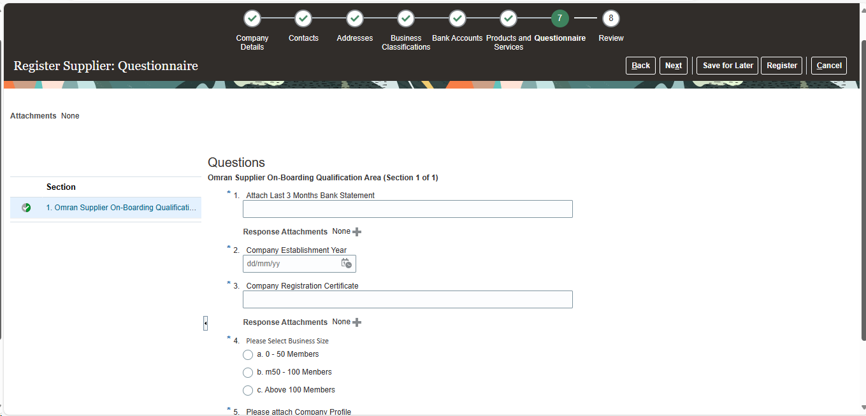
Step | Action
 | Navigate to “Review” Click on “Register”
 | End Of Procedure

